1. Open datasets.xlsx file. Go to the Data > New Query > From Other Sources > Blank Query

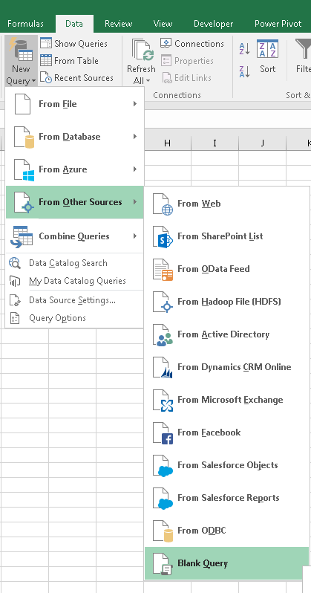

1. In the ‘Advance Editor’ window, paste the full content from script_executor.m file. Locate the script file get_automatic_update_log.m

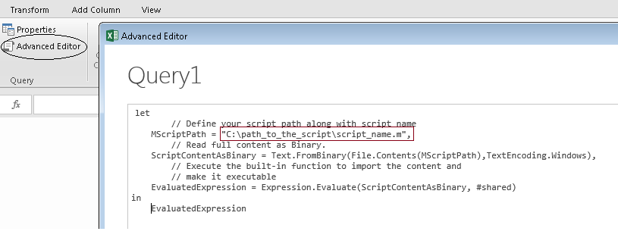

1. Press Done. Invoke the function will prompt for the folder location to track. Give the base folder location. Other subfolders under that folder will be automatically tracked.

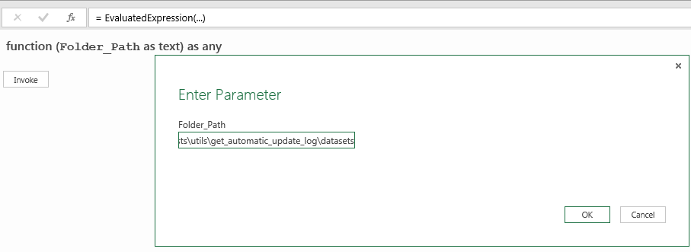

1. Press Okay. And the ‘Close & Load’

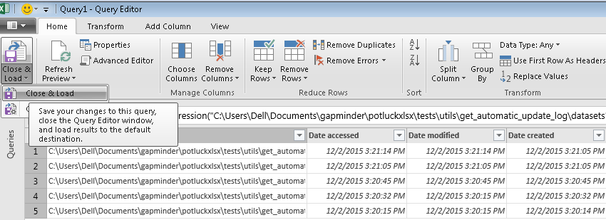

1. After that, if you change add/ modify any file/folder in that folder, it will be tracked automatically. Press the ‘Refresh’ to run the query again.

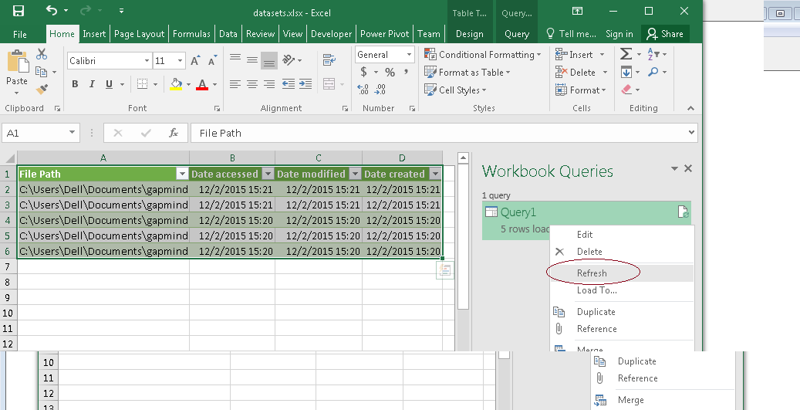

1. Do the same to track ‘src’ folder